**N O T I C E O F P U B L I C H E A R I N G**

TO ALL INTERESTED CITIZENS IN THE VILLAGE OF GRASS LAKE:

Please take notice that a public hearing to receive input on a **request for a rezoning** has been scheduled. The meeting has been set for **6:00 PM, Thursday, 9 January 2025** at the Village Office, 119 North Lake St., Village of Grass Lake.

The request involves the following property:

Parcel ID: 008-10-33-451-014-00

Address: 165 East Ave., Grass Lake

Applicant: John P. Murray & Pamela Murray

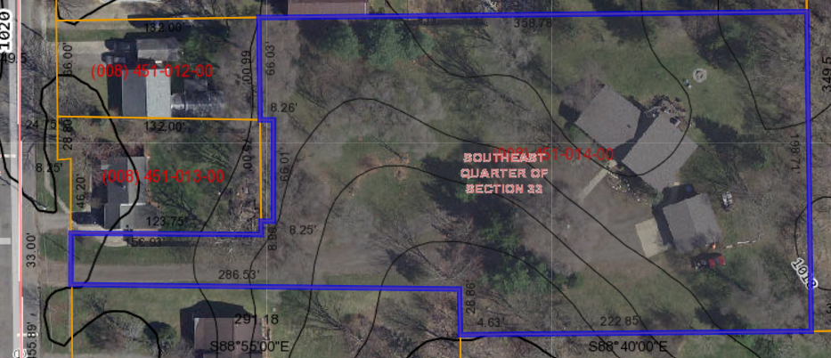

Request: a Special Use Permit to establish a Group Child Day Care Home.

Comments in person will be received by the Commission at the Public Hearing. Comments in writing may be directed to the Village Planning Commission, Village of Grass Lake, PO Box 737, Grass Lake MI 49240 prior to the hearing date.

Your participation is appreciated!

By order:

Richard K. Rabeler, Chair

Planning Commission